

STAREHE GIRLS’ 2025 PREDICTION
POSSIBLE KCSE EXAM
443/2
AGRICULTURE
PAPER 2 (THEORY)
TIME: 2 HOUR
NAME……………………………………………………………………………………….
SCHOOL……………………………………………… SIGN………………………..
INDEX NO……………………………………………. ADM NO……………………
(Kenya Certificate of Secondary Education)
Instructions to students
- Write your name and Admission number in the spaces provided at the top of this page
- This paper consists of three sections: A , B and C
- Answer all questions in sections A and B
- Answer any two questions in section C
- All answers should be written in the spaces provided
- Candidate should answer the questions in English

SECTION A (30 MARKS)
Answer all the questions in this section in the spaces provided
- State four roles of worker bees in a bee colony. (2 marks)
…………………………………………………………………………………………………………
…………………………………………………………………………………………………………
…………………………………………………………………………………………………………
…………………………………………………………………………………………………………

- Name a tool used for : (1 mark)
- Tightening barbed wire.
…………………………………………………………………………………………..
…………………………………………………………………………………………..
- Digging and collecting manure.
……………………………………………………………………………………………………………………………………………………………………………………

- List four routes through which pathogens can enter the body of an animal. (2 marks)
…………………………………………………………………………………………………………
…………………………………………………………………………………………………………
…………………………………………………………………………………………………………
…………………………………………………………………………………………………………

- What is the name given, whereby hind legs come out first during parturition? (1 mark)
…………………………………………………………………………………………………………

- Give two functions of Kenya Meat Commission (KMC). (1 mark)
…………………………………………………………………………………………………………
…………………………………………………………………………………………………………

- Name a breed of pig which has the following characteristic.
- Black body with a white patch on the shoulders and the forelegs. (½ mark)
………………………………………………………………………………………

- White body with blue spots. (½ mark)
………………………………………………………………………………………

- Mention two tools used in cutting mature horns in cattle. (1 mark)
…………………………………………………………………………………………………………
…………………………………………………………………………………………………………

- Name the other combination of tool used together with each of the following tools. (2 marks)
- Canula…………………………………………………………………………………….
- Brace……………………………………………………………………………………..
- Elastrator…………………………………………………………………………………
- Wood chisel………………………………………………………………………………

- Give four factors that would affect digestibility of food in livestock. (2 marks)
…………………………………………………………………………………………………………
…………………………………………………………………………………………………………
…………………………………………………………………………………………………………
…………………………………………………………………………………………………………

- State two reasons why the wire loop hanging in Kenya Top Bar Hive (K.T.B.H) is recommended to be smeared with grease. (1 mark)
…………………………………………………………………………………………………………
…………………………………………………………………………………………………………
…………………………………………………………………………………………………………

- State four reasons of castration in pig production. (2 marks)
…………………………………………………………………………………………………………
…………………………………………………………………………………………………………
…………………………………………………………………………………………………………
…………………………………………………………………………………………………………
…………………………………………………………………………………………………………
- Distinguish between the following practices as used in livestock production.
- Crutching and ringing in sheep management. (2 marks)
…………………………………………………………………………………………………………
…………………………………………………………………………………………………………
…………………………………………………………………………………………………………
- Cropping and harvesting in fish farming. (2 marks)
…………………………………………………………………………………………………………
…………………………………………………………………………………………………………
…………………………………………………………………………………………………………

- State three aspects to examine in the dung to determine ill health in livestock. (1 ½ marks)
…………………………………………………………………………………………………………
…………………………………………………………………………………………………………
…………………………………………………………………………………………………………

- List four farm structures that are necessary for handling dairy animals. (2 marks)
…………………………………………………………………………………………………………
…………………………………………………………………………………………………………
…………………………………………………………………………………………………………
…………………………………………………………………………………………………………

- Name the causal agent of the following livestock diseases. (2 marks)
- Anaplasmosis…………………………………………………………………………
- Anthrax………………………………………………………………………………
- Swine fever…………………………………………………………………………
- East coast fever………………………………………………………………………

- State three cultural uses of livestock. ( 1 ½ marks)
…………………………………………………………………………………………………………
…………………………………………………………………………………………………………
…………………………………………………………………………………………………………

- Name the intermediate host of the following endoparasites. (1 mark)
- Fasciola hepatica
………………………………………………………………………………………….
- Taenia saginata
…………………………………………………………………………………………..
- Give two advantages of natural mating in pig management. (1 mark)
…………………………………………………………………………………………………………
…………………………………………………………………………………………………………
- What is dry cow therapy? (1 mark)
…………………………………………………………………………………………………………
…………………………………………………………………………………………………………

SECTION B (20MARKS)
Answer all the questions in this section in the spaces provided
- The following photograph shows a poultry structure, study it carefully and answer the questions that follow.
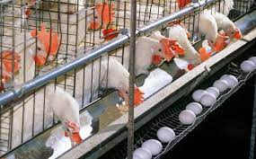

- Identify the structure shown above (1 mark)
…………………………………………………………………………………………………………

- Give three advantages of the above structure in poultry rearing. (3 marks)
…………………………………………………………………………………………………………
…………………………………………………………………………………………………………
…………………………………………………………………………………………………………
- Name any other structure used for rearing poultry (1 mark)
…………………………………………………………………………………………………………

- The diagrams below show farm tools. Study them and answer the questions that follow.
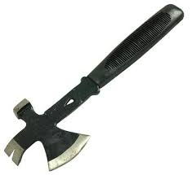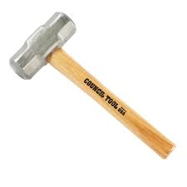
J K
- Identify tool J and K (2 marks)
…………………………………………………………………………………………………………………………………………………………………………………....
- State two uses of the tools shown above (2 marks)
…………………………………………………………………………………………………………
…………………………………………………………………………………………………………
…………………………………………………………………………………………………………
- Classify the tools under woodwork tools and equipment. (1 mark)
…………………………………………………………………………………………………………

- Below is a photograph of a bull. Study it carefully and answer the questions that follow.
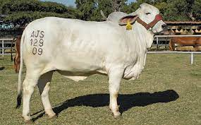

- Name two observable methods of identification (2 marks)
…………………………………………………………………………………………………………
…………………………………………………………………………………………………………

- State the name of the rope placed on the face around the head of the animal (1 mark)
…………………………………………………………………………………………………………

- State two observable characteristics of the bull shown above. (2 marks)
…………………………………………………………………………………………………………
…………………………………………………………………………………………………………

- Study the diagram below and answer the questions that follow
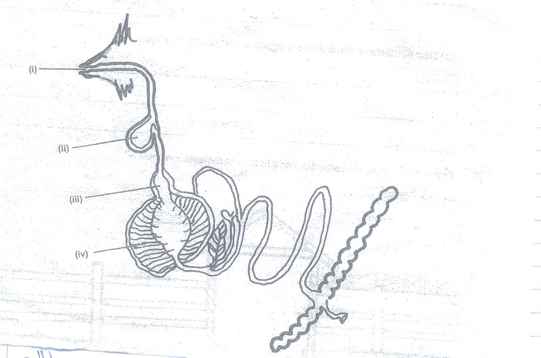

- The diagram above shows digestive system of a chicken (2 marks)
Name the parts labelled:
(i)………………………………………………………………………………………..
(ii)……………………………………………………………………………………….
(iii)………………………………………………………………………………………
(iv)………………………………………………………………………………………

- State two functions of part (i) above (2 marks)
…………………………………………………………………………………………………………
…………………………………………………………………………………………………………

- State two features that enable the organ (iv) to carry out its function (1 mark).
…………………………………………………………………………………………………………
…………………………………………………………………………………………………………
…………………………………………………………………………………………………………

SECTION C (40 MARKS)
Answer any two questions in this section in the spaces provided after question number 26.
- a) Discuss the management of day old chicks to the end of brooding. (10 marks)
b) Explain five functions of water in livestock nutrition . (5 marks)
c) Give the management practices carried out on a hedge grow/live fence. (5 marks)

- a) Outline the management practices carried out in a fish pond to ensure maximum harvest of fish. (7 marks)
b) State the mechanical methods used to control ticks. (5 marks)
c) Describe brucellosis disease in cattle under the following sub-headings:
- Casual organism. (1 mark)
- Symptoms of attack (3 marks)
- Control measures (4 marks)

- a) Explain six routine management practices carried out in rearing a dairy male calf.(6 marks)
b) Describe the procedure of milking using hand milking method. (8 marks)
c) Outline the factors that a farmer should consider when selecting materials for constructing a dairy cattle shed (6 marks)
THIS IS THE LAST PRINTED PAGE

